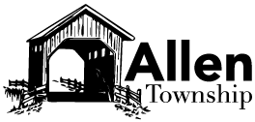**Community Day**

**September 15th, 2018**

**5:00 P.M. to 8:00 P.M.**

**16945 Allen Center Rd.**

C:\Users\Administrator\AppData\Local\Microsoft\Windows\Temporary Internet Files\Content.IE5\ANEHISRK\MC900445254[1].wmf

**Dinner Provided - Hog Roast**

**Entertainment**

**Corn Hole Tournament**

**Many Kids Activities such as:**

**Balloon Artist**

**Face Painting**

**Grandpa's Express Train**

**Bounce Obstacle Course**